Introduction
Civil Society and the “Enabling Environment”

The 2007 Enabling Environment Conference in Kabul outlined that “civil society is committed to the public good and is powered by private voluntary energies. It includes institutions of education, health, science and research which conduct activities and / or provide services on a charitable or non-commercial (but fee-paying) basis. It embraces professional, commercial, labour, ethnic and arts organisations, and others devoted to religion, communication (including media), the environment, and the community.”

In a speech made in 2016 to Africa’s business and government leaders gathered in Sharm el-Sheikh Egypt, His Highness the Aga Khan noted civil society “not only complements the work of the private and public sectors; it can often help complete that work”. He then highlighted the role of private and public sectors vis-à-vis civil society, saying “there is a great deal that leaders in the business sector and in government can do to strengthen the work of civil society, to help provide civil society with what I have called an ‘enabling environment’.”

The 2007 Enabling Environment Conference paper describes the concept of an enabling environment as being characterised by the following: “political stability; confidence in the future; mutual trust, understanding, dialogue and collaboration amongst stakeholders; rule of law; protection of the rights of citizens; a diversity of stable, democratic institutions; and a streamlined legal, fiscal, regulatory, and administrative framework governing all spheres of private initiative, which is predictably, consistently and impartially applied”.

Purpose of the Civil Society Monitor

This document provides AKDN staff global-level analyses and brief country-level summaries about the enabling environment for civil society in countries with a notable AKDN programme or institutional presence. As AKDN agencies play an important role in the development of civil society in most contexts, an understanding of the enabling environment, including trends, legislative measures and legal and regulatory frameworks, can serve to inform internal policies, institutional posture within a country or region, as well as programme direction. More practically, this document can serve as a useful quick reference for basic information about civil society in a given country, e.g., history, size, laws and registration authority.

Sources and focal points

The Aga Khan Foundation’s field offices provide the primary input for country summaries, and the Geneva office compiles the document, supplements analysis with desk research and prepares the Enabling Environment Index. Input from field teams is drafted in consultation with other AKDN agencies, notable civil society support institutions such as the Afghan Institute for Civil Society and the Pakistan Centre for Philanthropy, other local civil society institutions, research institutions and academics. The legal analysis in country summaries draws from material published by the International Center for Not-for-Profit Law (ICNL).

Global analysis

The Enabling Environment Index compiles and aggregates key indicators from global indexes and indicators which relate to principal characteristics of an enabling environment noted above. The data sources are elaborated in the section titled sources and definitions.

Country summaries

Each country summary includes the following:
- National context: Brief analysis about historical traditions, evolution, structure, gender equality and status of civil society in the country or region.
- Major national and regional trends: Notable trend(s) affecting civil society in the country or region.
- Legal and regulatory framework: The main laws and institutions governing civil society institutions.
- Recent and pending legislation: A brief summary of recent changes in legislation, proposed legislation or pending legislation that have implications for civil society institutions.
- Challenges facing civil society: A brief analysis of the key challenges affecting civil society.

Enabling Environment Index

The following table compiles data from global indexes and indicators relevant to the enabling environment (see sources and definitions for a list of indicators used).

The index considers macro level data and indicators related to the enabling environment, derived from major international reports. It should be noted that whilst global indices provide a certain degree of insight, because they typically do not delve deeper than the national-level, regional subtleties often are not reported. Similarly, important differences in rural and urban contexts are also under-reported. Nevertheless, general insights emerge about the principal characteristics of the enabling environment from these indicators.

Each country score, and characteristic sub-scores, are grouped into four categories: restrictive (0-24), challenging (25-49), supportive (50-74), enabling (75-100).

Enabling Environment Index  2018 | Political stability | Confidence in the future | Mutual trust | Understanding | Dialogue and collaboration | Rule of law | Citizen protections | Democratic institutions | Legal, fiscal, regulatory, admin frameworks |  | 2018 score | Score change from 2017
Afghanistan | 14 | 48 | 15 | 63 | 21 | 18 | 29 | 26 | 23 |  | 28 | +1
Bangladesh | 42 | 58 | 28 | 51 | 14 | 38 | 49 | 54 | 45 |  | 42 | -
Côte d’Ivoire | 44 | 47 | 34 | 70 | 20 | 37 | 47 | 39 | 43 |  | 42 | -1
Egypt | 34 | 69 | 32 | 43 | 16 | 40 | 39 | 34 | 44 |  | 39 | -
India | 40 | 62 | 40 | 57 | 25 | 49 | 61 | 72 | 55 |  | 51 | -1
Kazakhstan | 56 | 79 | 31 | 46 | 25 | 42 | 40 | 31 | 55 |  | 45 | -
Kenya | 38 | 56 | 28 | 69 | 25 | 39 | 50 | 51 | 50 |  | 45 | -
Kyrgyz Republic | 47 | 66 | 29 | 69 | 23 | 28 | 47 | 51 | 49 |  | 45 | -
Madagascar | 53 | 51 | 24 | 74 | 34 | 35 | 49 | 51 | 42 |  | 46 | -
Mali | 33 | 44 | 31 | 64 | 30 | 34 | 42 | 56 | 43 |  | 42 | -1
Mozambique | 47 | 42 | 25 | 69 | 42 | 30 | 45 | 40 | 39 |  | 42 | -1
Pakistan | 20 | 55 | 32 | 57 | 15 | 33 | 44 | 43 | 45 |  | 38 | -
Portugal | 72 | 84 | 63 | 86 | 60 | 73 | 86 | 78 | 66 |  | 74 | -
Russia | 35 | 80 | 29 | 50 | 18 | 34 | 37 | 32 | 54 |  | 41 | -
Syria | 14 | 54 | 14 | 21 | 1 | 10 | 0 | 14 | 17 |  | 16 | -2
Tanzania | 53 | 53 | 36 | 69 | 43 | 42 | 47 | 55 | 47 |  | 49 | -1
Uganda | 46 | 49 | 26 | 63 | 24 | 45 | 39 | 51 | 49 |  | 44 | +1

ENABLING ENVIRONMENT INDEX

The 2018 Enabling Environment Index scores summarised in the table above and the chart below convey the general status of the enabling environment for each country. Whilst there is variation amongst most countries on the characteristic sub-scores – highlighting relative weaknesses and strengths within countries – most countries assessed are considered to have “challenging” enabling environments. This could be due to a number of factors, including weak and restrictive government, unpredictable political and security environments, gaps in social cohesion and equality, limited citizen protections, ineffectual institutions, moderate or high levels of corruption, etc. Within such environments, civil society tends to lack the encouragement, the support, and legal protections necessary for it to thrive. Amongst nearly all countries assessed, “dialogue and collaboration” is amongst the weakest characteristics. This therefore underscores the need for efforts to create, nurture and strengthen spaces, platforms and networks whereby various actors in civil society, in addition to government and other private sector actors, can come together.

The 2018 scores note improvements in Uganda and Afghanistan and deteriorations in Côte d’Ivoire, India, Mali, Mozambique, Syria, Tajikistan and Tanzania. Possible explanations for these improvements and deteriorations are further elaborated in the country sections.
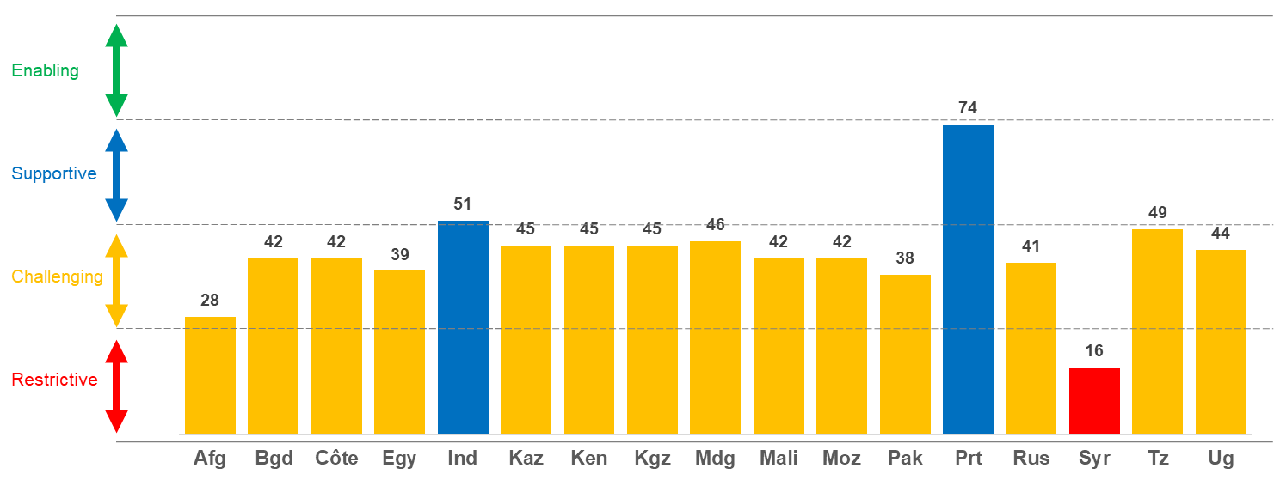
2018 score

Kyrgyz Republic |  | 45 | -
 |  | Challenging

Most favourable indicators | Understanding | Confidence in the future |  | Democratic institutions
Least favourable indicators | Dialogue / collaboration | Mutual trust |  | Rule of law
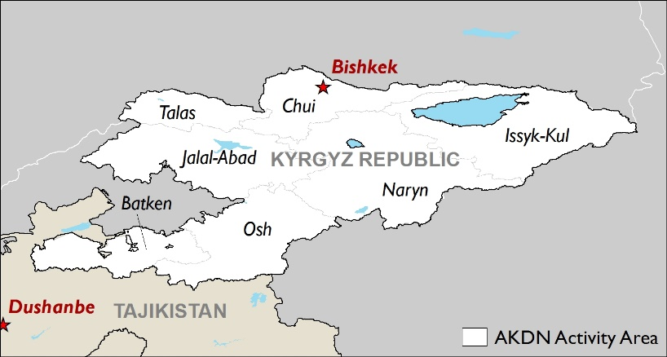 |  |  | Population
 |  |  | Total (urban, rural, <15) |  | 6 million (36%, 64%, 32%)
 |  |  | GDP per capita (2017) |  | $1,220
 |  |  | Civil Society Organisations
 |  |  | Number registered |  | 15,000
 |  |  | Principal scope |  | Social services
 |  |  | Registration authority |  | Ministry of Justice  State Tax Inspectorate
 |  |  | AKDN
 |  |  | Resident Representative |  | Yes
 |  |  | Agencies |  | AKAH, AKAM, AKES, AKF, AKFED, AKHS, AKTC, UCA

National context
Prior to the Soviet era, traditional forms of association played a significant role in the region, especially family and clan linkages. In Kyrgyz republic- one of most tribal groups, there is evidence of consensual decision-making, such as the election of leaders and the negotiation of pastureland. Historical institutions for decision-making included the aksakal (elder’s council) and the mahallas (district committees) as well as traditional practices like ashar (voluntary labour from the community for the community).

During the Soviet era, a variety of public organisations operated in the Kyrgyz Republic, including sports clubs, scientific societies, trade unions and associations. These were primarily professional organisations and were not oriented towards advocacy or political participation. After independence in 1991, international donors supported the emergence of a multitude of civil society organisations (CSO) in rural development, human rights, health and education. Throughout the 1990s, chaotic, short-term, financially unsustainable operations characterised the CSO landscape. Since then, CSO have become more sophisticated in their organisational development, long-term planning and project sustainability, but remain heavily reliant on international donors to sustain their operations. Civil society in the Kyrgyz Republic is the most vibrant and active in Central Asia, with a focus on human rights, health, environment, youth and sport, education and advocacy. Civil society organisations (CSOs) are registered as non-commercial organisations under a civil law.

Across Central Asia there has been a re-emergence of traditional views that a woman's place in society is lower than a man's and that men deserve the best jobs. Women in Kyrgyzstan continue to be excluded from many decision-making circles and violence against women is widespread in forms such as domestic violence and bride kidnapping. Despite these significant challenges, Kyrgyzstan has a legislative base that guarantees equal rights for men and women and an innovative gender equality strategy drafted in 2012. Additionally, according to study by United Nations Development Programme on Gender Equality and Women’s Empowerment in Public Administration in Kyrgyzstan, the women’s movement in Kyrgyzstan, made up of a network of NGOs, “has achieved remarkable success for gender equality and continues to be a driving force.”

Major national and regional trends
While political developments in the Kyrgyz Republic continue to facilitate a more enabling environment for civil society, there are signs of growing tensions ahead of the autumn 2017 presidential election, that have contributed to diminishing the space for free speech and civil society engagement. The government has alleged some CSOs as being foreign-funded, and "threatening" to the national security of Kyrgyz republic.

Security in the region remains relatively stable, although some monitoring groups warn of increasing radicalism, especially in the west and north of the country, linked to (i) opposition to the ruling party, (ii) enduring ethnic tensions, and (iii) lack of economic opportunity, amongst other factors. Periodic border disputes along the border with Uzbekistan might end due to ratification in September 2017 of the agreement with Uzbekistan by the Kyrgyz President on defining 85% of the border line.

The economy in the country continues to stagnate, similar to others in the region. Foreign direct investment has decreased since 2013, and the promised benefits of the Eurasian Economic Union have yet to materialise.

Taza Koom is a key component of the National Sustainable Development Strategy of Kyrgyz Republic until 2040, which is based on human capital and innovations in harmony with the environment. This high-tech programme aims to build an open and transparent state, where human life, rights, freedoms, health, education, raising life standard of citizens and improving business environment are at the centre.

Legal and regulatory framework
The Kyrgyz Republic has a more enabling legal and regulatory framework for CSOs, relative to other countries in the region. The country’s constitution (2010) declares “a right to freedom of association.” However, a constitutional referendum in December 2016 introduced amendments that could negatively impact the balance of powers by strengthening the powers of the executive while weakening both the parliament and, to a greater extent, the judiciary. These amendments were supported by about 80% of voters.

The Civil Code and the Law on Non-commercial Organisations establish the legal framework for civil society. The most common types of Non-Commercial Organisations (NCOs) in the country are public associations, foundations, institutions, associations or unions of legal entities and community based organisations. The Soros Foundation estimates 87% of the country’s CSOs are public associations / foundations.

There are no major legal barriers to establish CSOs in the country. CSOs register as NCOs per the legal framework set out in the NCO Law and Law on State Registration of Legal Entities. Operations are governed by stipulations set out in the Civil Code, NCO Law, and the Charter of Organisations. The Ministry of Justice is the administrative body responsible for approving the registration of NCOs. Registration is straightforward and generally takes 10 days. The cost of registration is a nominal amount ($6).

Due to complicated procedures related to dissolution, many CSOs in the Kyrgyz Republic are inactive but retain their registration. According to the Ministry of Justice, in 2016 there were over 15,000 CSOs registered in the Kyrgyz Republic, yet fewer than 600-700 are operational. Of these, 400 are based in Bishkek. There are also a large number of community groups across the country.

The legal framework for taxation is not particularly favourable for CSOs. CSO can engage legally in economic activity, but most have to pay the same tax rates as commercial entities. Although according to legislation, corporations and individuals can deduct up to 10% of the amount they donate to charitable organisations from their income taxes. However, no CSOs in the country qualify as charitable organisations since the Law on Arts Patronage and Charitable Activities stipulates provisions that are incredibly difficult to achieve. For instance, CSO wishing to maintain charitable status are required to use 98% of their income for charitable purposes.

Recent and pending legislation
In March 2017, the parliament adopted the Law on State Procurement of Social Services. The law is pending the signature of the president. Four secondary legal acts to this law are also being developed in Parliament, including regulations on procedures of social services delivery via social voucher; monitoring and assessment of implementation of projects for public benefit; procedures for conducting a competition of public benefit projects; and web portal for state grants for financing projects for public benefit. Once adopted, this law will improve procedures for government financial support to CSOs providing social services to the population.

Challenges facing civil society
The primary challenge facing civil society in Kyrgyzstan is a lack of adequate and sustainable funding for CSOs, Other challenges include: (i) retaining staff; (ii) access to technology; (iii) adequate legal support; (iv) organisational capacity; and (v) limited partnerships and limited diversity of services. Collective self-regulation or certification of CSOs is an increasing priority, though some CSOs see self-regulation as an imported model and have concerns about who will conduct certification and who will set the standards.

Although the government adopted the Law on Social Services Contracting in 2008 to allow the state to use funds to engage CSOs in social service delivery, the volume of financing has been low due to the country’s economic hardships and deficiencies in implementation. Philanthropy and crowdfunding is non-existent due to economic conditions and poor implementation of tax legislation. CSOs have the right to carry out economic activities, but the resulting income is taxable unless the CSO qualifies as a charitable organisation, which is difficult to maintain because of operational restrictions.

Sources and definitions

Sources used for Enabling Environment Index

Indicators | Source(s) | Year | # of countries assessed | Definitions
- Political stability
Political stability | World Bank World Governance Indicators | 2016 | 215 | Perceptions of the likelihood government will be destabilised or overthrown unconstitutionally or violently, including by violence and terrorism.
Global Peace Index | Institute for Economics and Peace | 2018 | 162 | The dimensions of the index are: (i) ongoing domestic and international conflict; (ii) societal safety and security; (iii) militarisation. The index is composed of 22 indicators from external sources.

- Confidence in the future
Human Development Index | United Nations Development Programme | 2016 | 186 | Measures human development by examining three dimensions: (i) a long healthy life (life expectancy at birth); (ii) education (mean years of schooling, expected years of schooling); and (iii) standard of living (gross national income at purchasing power parity per capita). Countries are ranked into four tiers of human development: very high, high, medium and low.

- Mutual trust
Corruption Perceptions Index | Transparency International | 2017 | 177 | Ranks countries and territories based on how corrupt their public sector is perceived to be. Each score indicates perceptions by country.

- Understanding
Press Freedom Index | Reporters Without Borders | 2018 | 180 | Ranks countries according to media pluralism, media independence, environment and self-censorship, legislative framework, transparency, infrastructure and violence against journalists, netizens or media assistants.

- Dialogue and collaboration amongst stakeholders
Group grievances | Fund for Peace Fragile States Index | 2018 | 186 | Measures include: discrimination, powerlessness, ethnic violence, communal violence, sectarian violence and religious violence.
Factionalised elites | Fund for Peace Fragile States Index | 2018 | 186 | Measures include: power struggles, defectors, flawed elections and political competition.
World Giving Index | Charities Aid Foundation | 2017 | 135 | Considers the scope and nature of giving by asking whether respondents have done any of the following in the past month: (i) donated money to a charity; (ii) volunteered time to an organisation; and (iii) helped a stranger or someone they didn’t know who needed help.

- Rule of law
Rule of law | World Bank Governance Indicators | 2016 | 215 | Perceptions of the extent agents have confidence in and abide by societal rules. Specifically, contract enforcement, property rights, police, courts, and crime and violence.

- Protection of the rights of citizens
Social Progress Index | Social Progress Index | 2017 | 132 | Measures the social and environmental performance of societies according to three dimensions of the index: (i) basic human needs: nutrition and medical care, water and sanitation, shelter, personal safety; (ii) foundations of wellbeing: access to basic knowledge, access to information and communications, health and wellness, ecosystem sustainability; and (iii) opportunity: personal rights, personal freedom and choice, tolerance and inclusion, access to advanced education. The index is a composite of 54 indicators collected by external institutions.
Freedom in the World | Freedom House | 2018 | 195 | Assesses the rights and freedoms enjoyed by individuals, rather than governments or government performance. Political rights and civil liberties can be affected by both state and non-state actors, including insurgents and other armed groups.

- A diversity of stable, democratic institutions
Democracy Index | The Economist Intelligence Unit | 2017 | 167 | Measures the state of democracy based on 60 indicators grouped according to the following five categories: electoral process and pluralism, civil liberties, functioning of government, political participation and political culture.

- Streamlined legal, fiscal, regulatory, and administrative framework
Global Competitiveness | World Economic Forum | 2017-2018 | 144 | Provides insight into the drivers of economic productivity and prosperity. Specifically, the institutions, policies, and factors that set the sustainable short- and medium-term levels of prosperity.
Regulatory quality | World Bank Governance Indicators | 2016 | 215 | Reflects perceptions of the ability of the government to formulate and implement sound policies and regulations that permit and promote private sector development.

Other key sources consulted

- International Center for Non-Profit Law Civic Freedom Monitor, http://www.icnl.org/research/monitor

- USAID Civil Society Sustainability Index

- World Bank: Data, http://data.worldbank.org

All scores have been converted to a base-100 value and re-calculated so that for each, zero represents the lowest possible score and 100 the highest score.

